***for* loop Scripts:**

1. **Simple for loop output**

#!/bin/bash

for i in 1 2 3 4 5

do

echo "Welcome $i times"

done

create a script file name

write a script as above

give permissions to script file

save it

execute the scriptfile

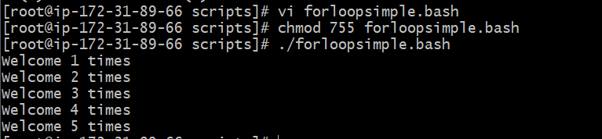

Now change the script as below and research

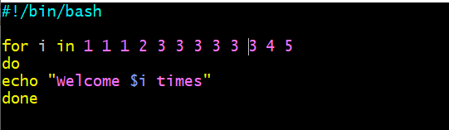

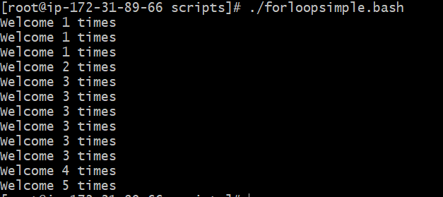

1. **Simple for loop output**

#!/bin/bash

for i in eat run jump play

do

echo See Imran $i

done

see here for is a loop command and do is a starting loop and checking the variable in I index and echo is giving out telling how many repeated task Imran is doing.

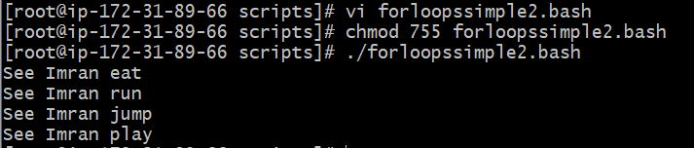

1. **for loop to create 5 files named 1-5**

#!/bin/bash

for i in {1..5}

do

touch $i

done

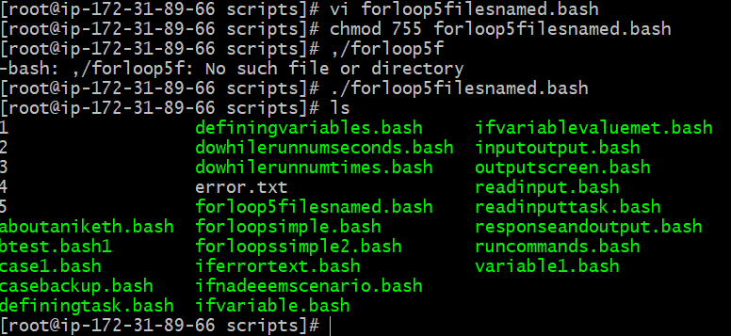

1. **for loop to delete 5 files named 1-5**

#!/bin/bash

for i in {1..5}

do

rm $i

done

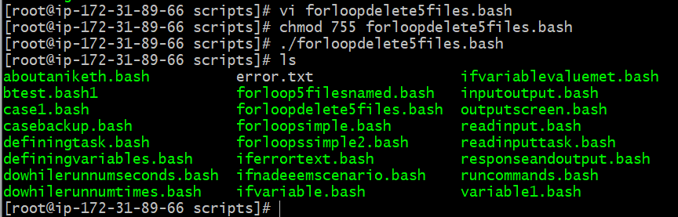

Here you are not able to the deleted files as previously it was created by giving name of the file 1, 2, 3 4 5

1. **Specify days in for loop**

#!/bin/bash

i=1

for day in Mon Tue Wed Thu Fri

do

echo "Weekday $((i++)) : $day"

done

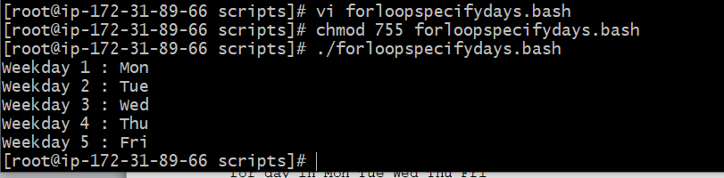

• for loop → to loop through day names.

• day → variable that takes each day's name.

Example: instead of I you can give count, num etc.,

• count → variable used to print the weekday number.

• count=$((count + 1)) → increments the number after each loop.

1. **List all users one by one from /etc/passwd file**

#!/bin/bash

i=1

for username in `awk -F: '{print $1}' /etc/passwd`

do

echo "Username $((i++)) : $username"

done

